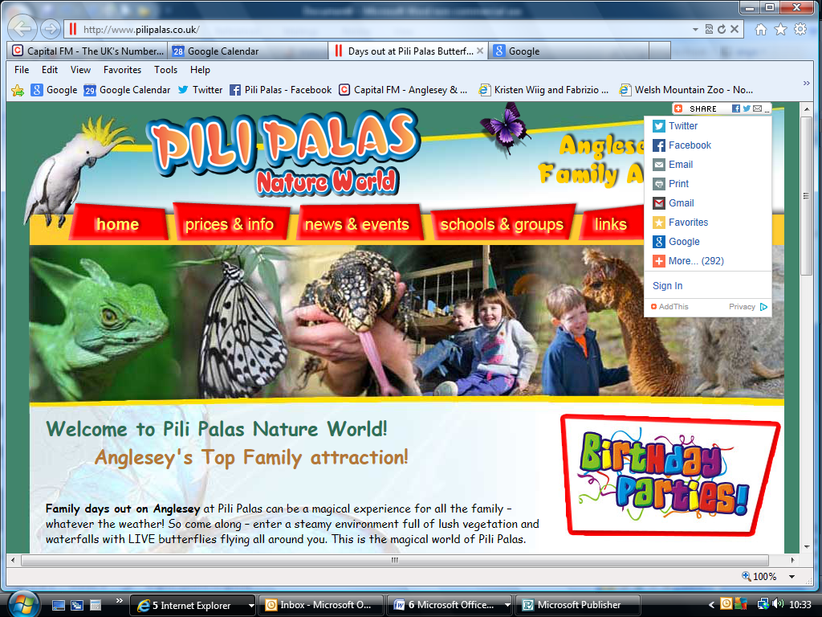
APPLICATION FORM

DATE:

POSITION:

FULL NAME:

DATE OF BIRTH:

ADDRESS:

CONTACT NUMBER:

EDUCATION/
QUALIFICATIONS

LANGUAGE SPOKEN:

HOLIDAYS BOOKED:

PREVIOUS
EXPERIENCE:

REFERENCES:

AVAILABLE DATE
TO START:

